Quantum Convolutional Neural Networks (QCNNs)

1. Problem
In many machine learning tasks, especially those involving structured or spatial data, it is important to learn local features and combine them hierarchically. Classical Convolutional Neural Networks (CNNs) achieve this using convolution and pooling layers.
Quantum Convolutional Neural Networks (QCNNs) aim to solve similar problems by processing quantum data (or classically encoded data) using local quantum operations, enabling efficient learning of hierarchical quantum features.

2. Intuition
QCNNs are the quantum analogue of classical CNNs:
- Convolution layers apply the same local quantum operations across qubits (parameter sharing)
- Pooling layers reduce the number of qubits while retaining relevant information
- Repeating these layers builds hierarchical representations
QCNNs are particularly suited for: - Quantum state classification - Detecting phases of matter - Learning local correlations in quantum systems

3. Circuit Structure
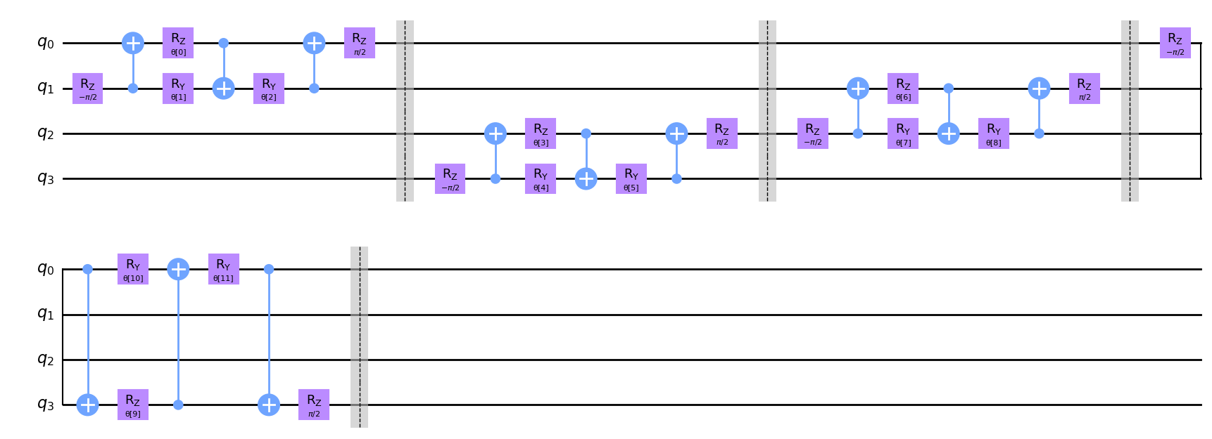
A QCNN circuit alternates between convolution and pooling layers.
- Input Encoding
Classical or quantum data is encoded into an initial quantum state.
- Convolution Layer
Parameterized two-qubit gates applied locally with shared parameters.
- Pooling Layer
Controlled operations followed by discarding (or measuring) some qubits.
- Repetition
Convolution–pooling blocks are repeated hierarchically.
- Measurement
Final qubits are measured to produce classification outputs.

4. Simple Math Involved
- State transformation: [ |{l+1}= U{}^{(l)} U_{}^{(l)} |_l ]
- Prediction: [ y = _L | O | _L ]
- Training objective: [ __i L(y_i, y_i^{}) ]
where: - (U_{}): convolution unitary - (U_{}): pooling unitary - (L): classical loss function

5. Python Code (QCNN – Algorithm)
Platform-agnostic execution code suitable for learning platforms
import numpy as np
from qiskit import QuantumCircuit
from qiskit.circuit.library import ZZFeatureMap
from qiskit.primitives import Sampler
from qiskit_machine_learning.neural_networks import SamplerQNN
from qiskit_machine_learning.algorithms.classifiers import NeuralNetworkClassifier
from qiskit_machine_learning.optimizers import COBYLA
X_train = np.array([
[0.1, 0.2, 0.1, 0.2],
[0.2, 0.1, 0.2, 0.1],
[0.8, 0.9, 0.8, 0.9],
[0.9, 0.8, 0.9, 0.8]
])
y_train = np.array([0, 0, 1, 1])
num_qubits = 4
qc = QuantumCircuit(num_qubits)
feature_map = ZZFeatureMap(feature_dimension=num_qubits, reps=1)
qc.compose(feature_map, inplace=True)
for i in range(0, num_qubits, 2):
qc.cx(i, i + 1)
qc.ry(np.pi / 4, i + 1)
qc.cx(1, 0)
qc.cx(3, 2)
sampler = Sampler()
qnn = SamplerQNN(
circuit=qc,
sampler=sampler,
input_params=feature_map.parameters,
weight_params=qc.parameters,
)
optimizer = COBYLA(maxiter=100)
classifier = NeuralNetworkClassifier(
neural_network=qnn,
optimizer=optimizer
)
classifier.fit(X_train, y_train)
X_test = np.array([
[0.05, 0.1, 0.05, 0.1],
[0.85, 0.9, 0.85, 0.9]
])
predictions = classifier.predict(X_test)
print("Predicted labels:", predictions)

6. Where the Algorithm Is Useful
- Quantum state classification
- Detecting phases of matter
- Learning local correlations in quantum systems
- Quantum many-body physics
- Research in quantum machine learning

7. Limitations
- No proven quantum advantage
- Circuit design is problem-specific
- Training can be slow and unstable
- Sensitive to noise
- Limited scalability on current hardware

8. Comparison with Classical CNNs
- Convolution: Classical CNNs use classical filters; QCNNs use local quantum gates
- Pooling: Classical pooling reduces pixels; quantum pooling reduces qubits
- Data type: Classical CNNs process images; QCNNs process quantum states
- Maturity: Classical CNNs are highly optimized; QCNNs are experimental

9. One-Sentence Summary
A Quantum Convolutional Neural Network learns hierarchical features using local quantum convolution and pooling operations, inspired by classical CNNs.

